9. ReactJS-HOL

**Solution:**

Step 1: **Creating** the **React-app** (npx create-react-app **cricketapp**)

Step 2: Creating **Player-components**:

1. **ListOfPlayers.js**
2. **ScoreBelow70.js**

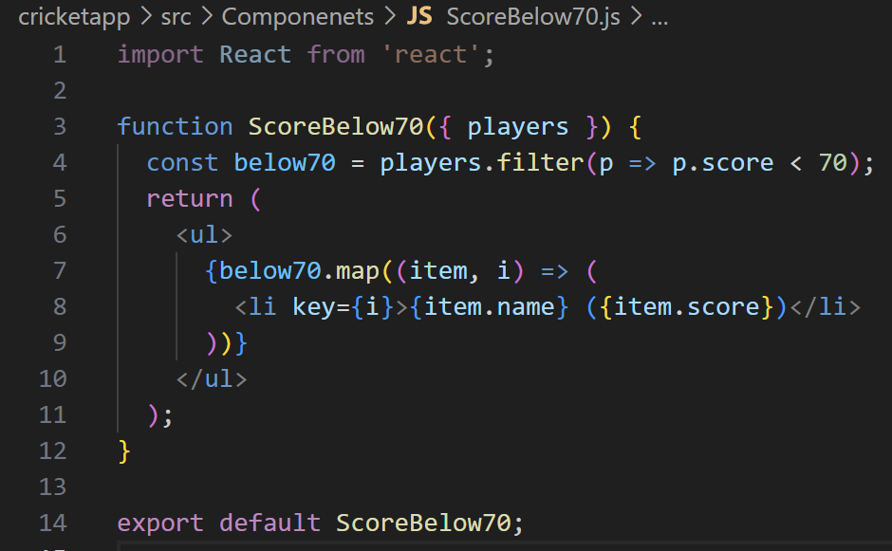

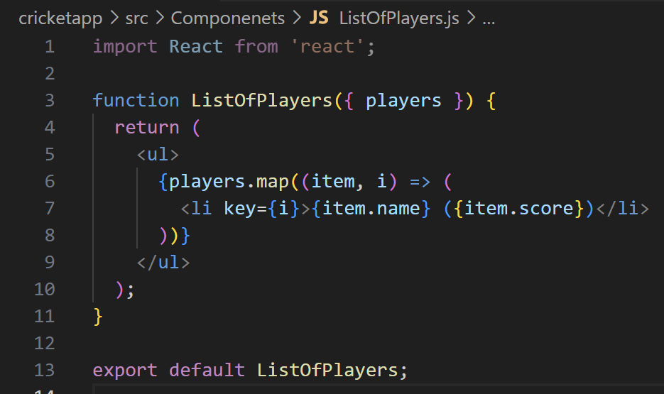

1. **OddPlayers.js**

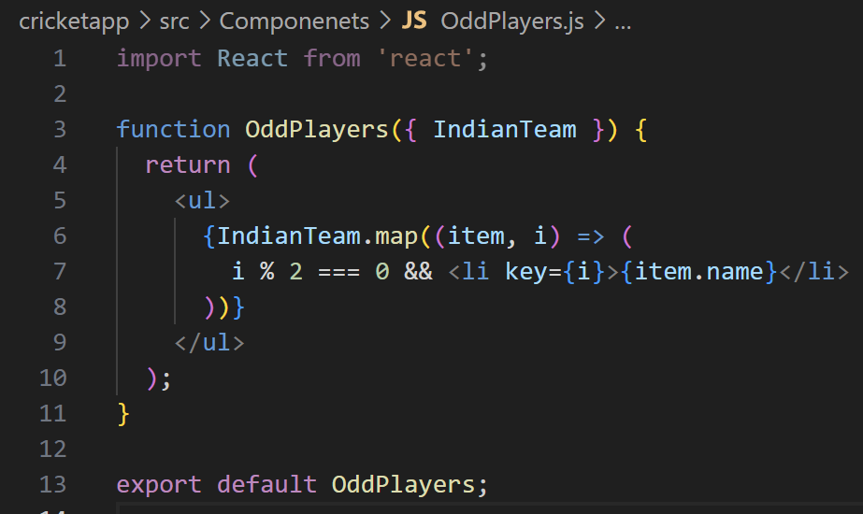

1. **EvenPlayers.js**

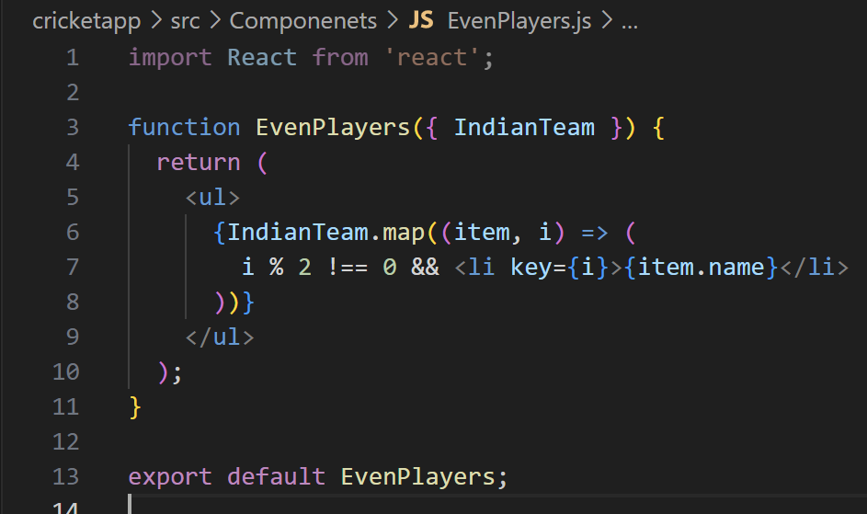

1. **IndianPlayers.js**
2. 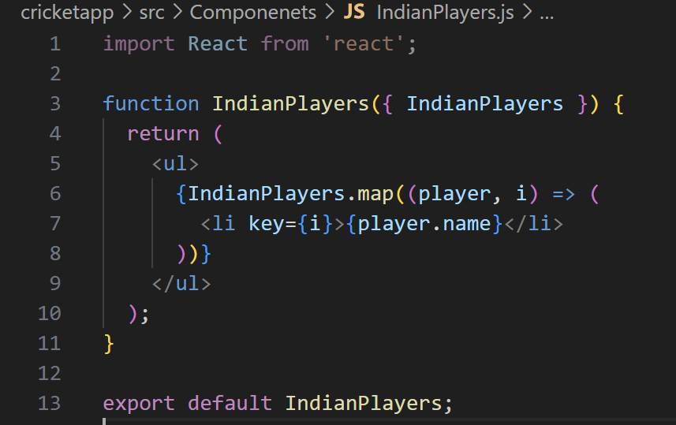**IndianPlayers.js**

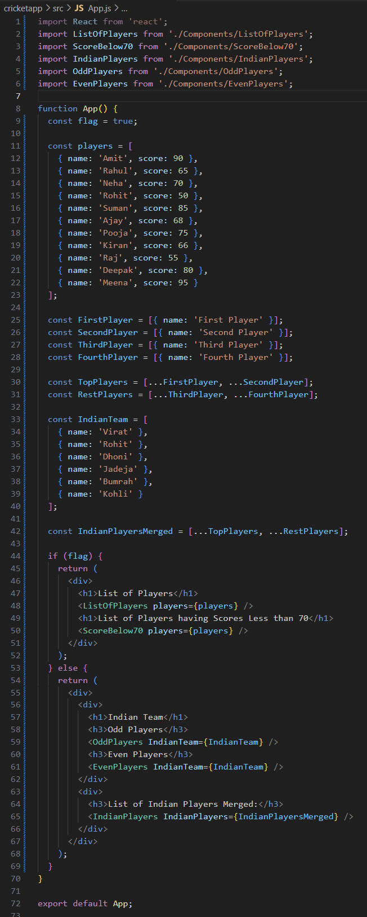Step 3**: Main App Component (App.js)**

**Step 4: Final Output 🡪**

1. 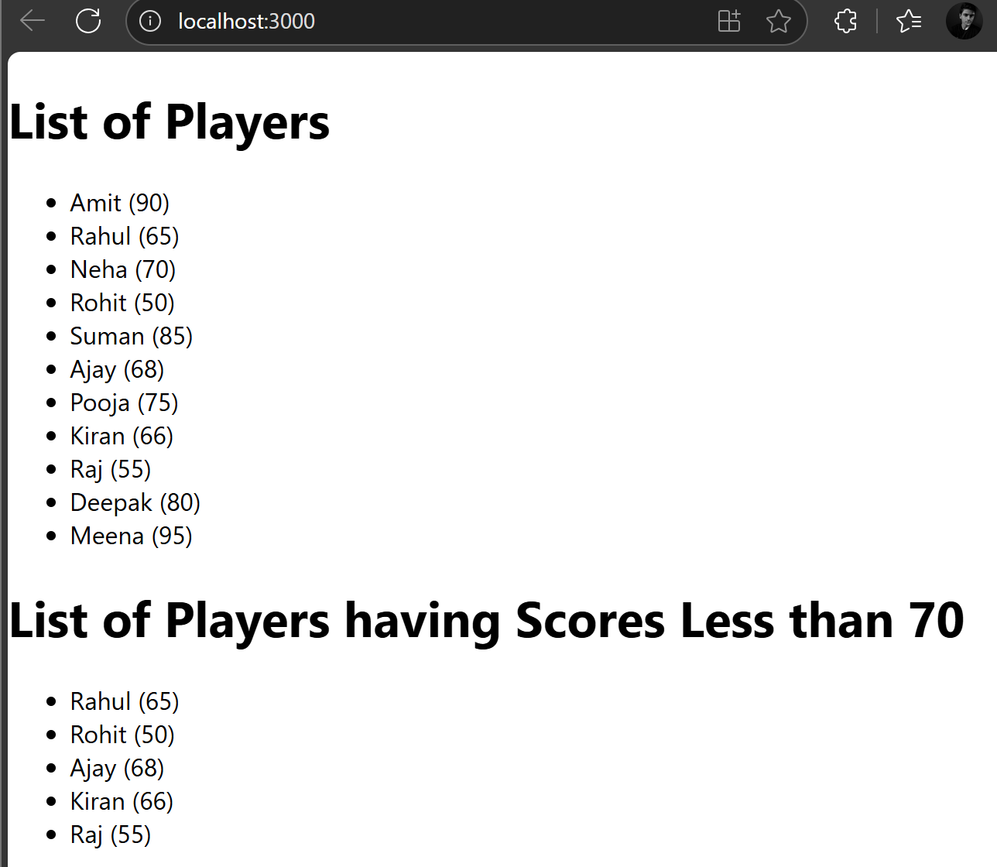When (**Flag == true)**
2. When **(Flag == false)**

